CUSTOMER DATA ANALYSIS

1. Project Overview
This project analyzes customer shopping behavior using transactional data collected from shopping malls between 2021 and 2023. The objective is to understand customer demographics, purchasing patterns, product preferences, and payment behavior in order to generate meaningful business insights and recommendations.

2. Dataset Summary
- Dataset contains customer transaction records
- Key Attributes:
  - Customer demographics (Age, Gender)
  - Product details (Category, Quantity, Price)
  - Transaction details (Invoice Date, Payment Method, Shopping Mall)

3. Data Preparation
The dataset was analyzed using Power BI Public:
- Created Revenue = Price × Quantity
- Created Age Groups
- Removed null values
- Aggregated data for analysis

4. Data Analysis

4.1 Shopping Distribution by Gender
Query:
SELECT gender, COUNT(*) AS total
FROM customer
GROUP BY gender;
Output:
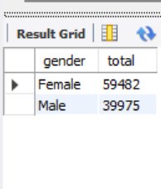
Insight:
Female customers have higher shopping activity compared to male customers.

4.2 Products Sold by Gender
Query:
SELECT gender, SUM(quantity) AS total_products
FROM customer
GROUP BY gender;
Output:
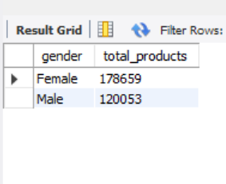
Insight:
Female customers purchased more products than male customers.

4.3 Revenue by Gender
Query:
SELECT gender, SUM(price * quantity) AS revenue
FROM customer
GROUP BY gender;
Output:
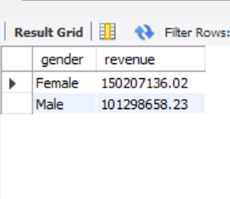
Insight:
Female customers generated more revenue than male customers.

4.4 Category Distribution
Query:
SELECT category, COUNT(*) AS total_sales
FROM customer
GROUP BY category
ORDER BY total_sales DESC;
Output:
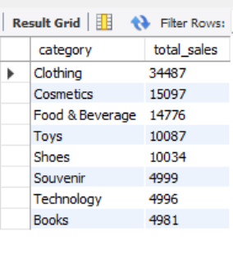
Insight:
Clothing is the highest-selling category.

4.5 Shopping Distribution by Age
Query:
SELECT age, COUNT(*) AS total_customers
FROM customer
GROUP BY age
ORDER BY age;
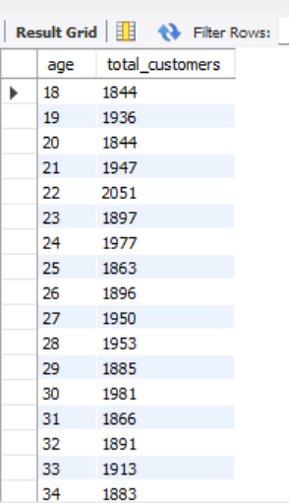
Insight:
Shopping activity varies across age groups, with middle-aged customers dominating.

4.6 Products Sold by Age Category
Query:
SELECT
CASE
WHEN age <= 18 THEN 'Teen'
WHEN age <= 25 THEN 'Young Adult'
WHEN age <= 35 THEN 'Adult'
WHEN age <= 45 THEN 'Mid-Age'
WHEN age <= 60 THEN 'Senior'
ELSE 'Elder'
END AS age_group,
SUM(quantity) AS total_products
FROM customer
GROUP BY age_group
ORDER BY total_products DESC;
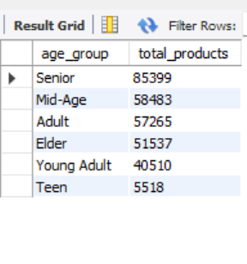
Insight:
Middle-aged customers purchase more products compared to other groups.

4.7 Revenue by Age Category
Query:
SELECT
CASE
WHEN age <= 18 THEN 'Teen'
WHEN age <= 25 THEN 'Young Adult'
WHEN age <= 35 THEN 'Adult'
WHEN age <= 45 THEN 'Mid-Age'
WHEN age <= 60 THEN 'Senior'
ELSE 'Elder'
END AS age_group,
SUM(price * quantity) AS revenue
FROM customer
GROUP BY age_group
ORDER BY revenue DESC;
Output:
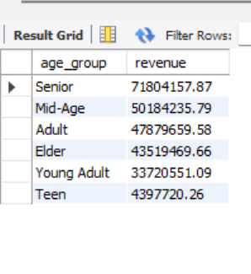
Insight:
The 46–60 age group generates the highest revenue.

4.8 Category Distribution with Other Variables
Query 1:
SELECT category, gender, COUNT(*) AS total_sales
FROM customer
GROUP BY category, gender
ORDER BY category;
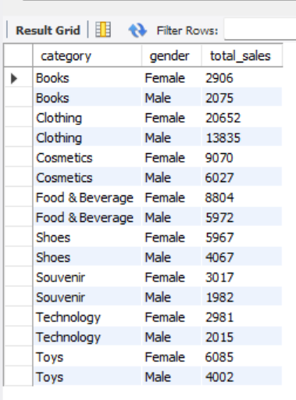
Query 2:
SELECT
CASE
WHEN age <= 18 THEN 'Teen'
WHEN age <= 25 THEN 'Young Adult'
WHEN age <= 35 THEN 'Adult'
WHEN age <= 45 THEN 'Mid-Age'
WHEN age <= 60 THEN 'Senior'
ELSE 'Elder'
END AS age_group,
category,
COUNT(*) AS total_sales
FROM customer
GROUP BY age_group, category
ORDER BY age_group;
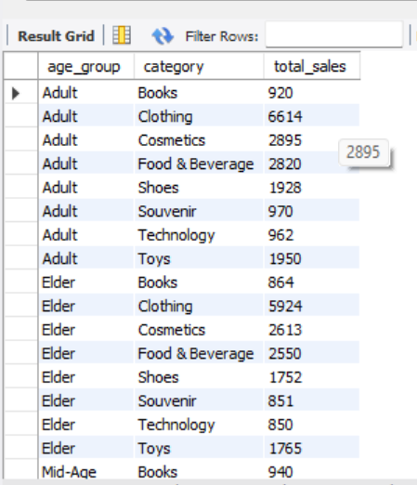
Query 3:
SELECT category, payment_method, COUNT(*) AS total_sales
FROM customer
GROUP BY category, payment_method
ORDER BY category;
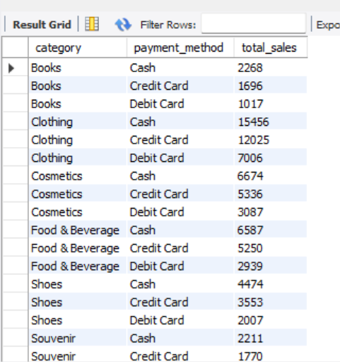
Insight:
Clothing remains the dominant category across gender, age groups, and payment methods.

4.9 Payment Method Relationship
Query 1:
SELECT payment_method, gender, COUNT(*) AS total
FROM customer
GROUP BY payment_method, gender;
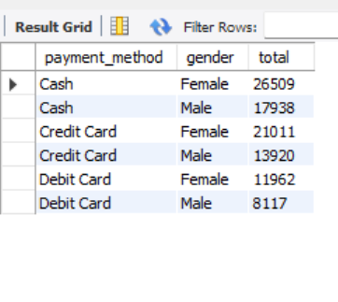
Query 2:
SELECT payment_method, SUM(price * quantity) AS revenue
FROM customer
GROUP BY payment_method;
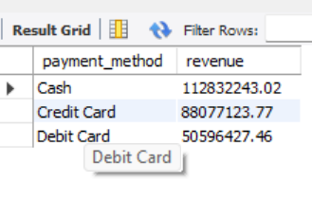
Insight:
Payment method usage varies across gender, with cash generating the highest revenue.

4.10 Payment Method Distribution
Query:
SELECT payment_method, COUNT(*) AS total
FROM customer
GROUP BY payment_method;
Output:
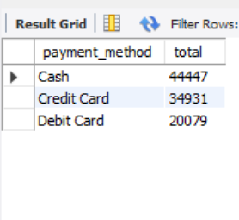
Insight:
Cash is the most commonly used payment method, followed by credit and debit cards.

4.11 Visualization and Dashboard Insights
The data was visualized using Power BI through an interactive dashboard.
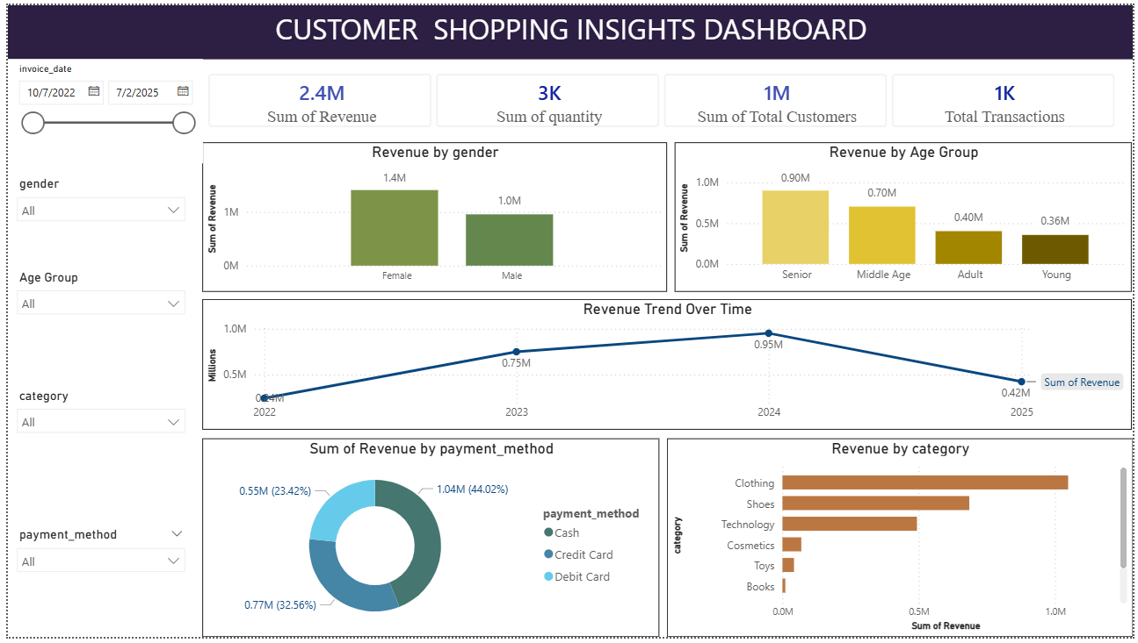

Key Insights:
- Revenue is highest among senior customers
- Female customers contribute more revenue
- Clothing and Shoes dominate sales
- Cash is the most used payment method
- Revenue peaked in 2024

5. Business Recommendations
- Focus marketing on female customers
- Target middle-aged customers
- Promote clothing category
- Encourage digital payments
- Use seasonal trends for campaigns

6. Conclusion
The analysis highlights key patterns in customer behaviour. Female customers and middle-aged groups are the primary contributors to revenue. Clothing dominates product categories, and cash remains the preferred payment method. These insights can help businesses improve decision-making and profitability.

7. Dataset Source
The dataset was obtained from a MySQL database using provided credentials and processed further using CSV format for analysis and visualization.

